**ARYAMAN MISHRA**

**19BCE1027**

1)C.java

package mypack;

interface A

{

public void Draw();

}

interface B extends A

{

public void Draw2();

}

public interface C extends B

{

public void Draw3();

}

D.java

package pack;

import mypack.*;

class X implements C

{

public void Draw()

{

System.out.println("This is 1st Draw function from Interface A.");

}

public void Draw2()

{

System.out.println("This is 2nd Draw function from Interface B.");

}

public void Draw3()

{

System.out.println("This is 3rd Draw function from Interface C.");

}

}

public class D

{

public static void main(String args[])

{

X a1=new X();

a1.Draw();

a1.Draw2();

a1.Draw3();

}

}

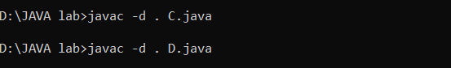

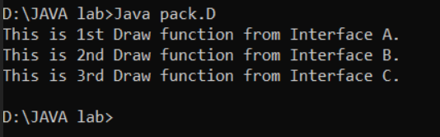

2)

2)Engine.java

package mypack2;

interface Engine

{

public void Start1();

public void Stop1();

}

PetrolLelo.java

package pkg;

import mypack2.*;

import java.util.*;

class PetrolEngine implements Engine

{

public void Start1()

{

System.out.println("starting engine...");

}

public void Stop1()

{

System.out.println("stopping engine...");

}

}

public class PetrolLelo

{

public static void main(String args[])

{

Scanner sc=new Scanner(System.in);

PetrolEngine ob=new PetrolEngine();

ob.Start1();

System.out.println("Enter Speed of Vehicle.");

double speed=sc.nextDouble();

System.out.println("Enter Distance Covered by Vehicle.");

double dist=sc.nextDouble();

double fuel=dist/speed;

System.out.println("Fuel Usage="+fuel+" litres.");

ob.Stop1();

}

}

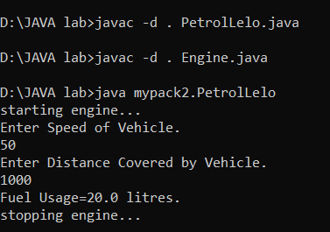

3)BankInfo.java

package mypack3;

interface BankInfo

{

public void Savings();

public void Current();

}

BankMoney.java

package mypack3;

import mypack3.*;

import java.util.*;

class BankStuff implements BankInfo

{

int deposit;

public void Savings()

{

System.out.println("10% Interest for Savings Account.Limit is 5000.");

System.out.println("Account Created.");

}

public void Current()

{

System.out.println("25% Interest for Savings Account.Limit is 500.");

System.out.println("Account Created.");

}

}

public class BankMoney

{

public static void main(String args[])

{

Scanner sc=new Scanner(System.in);

BankStuff ob=new BankStuff();

System.out.println("Enter 1 for Savings Account,2 for Current Account.");

int choice=sc.nextInt();

if(choice==1)

{

ob.Savings();

}

else

{

ob.Current();

}

}

}

